Process Name: vsim_mdn_load
System Name: network_migration
Workflow Name: W_vsim_mdn_load
Test Cases:
Test Id | Module Tested | Condition Tested | Test Data - Specify Modifications | Expected Results | Actual Results | Reviewed By
 | Network_Migration | Success email test. | Added team members email ids for testing purpose to receive success email. | Success email should be received. | As expected, email received.  Please refer below screen shot.

Screen Shot:
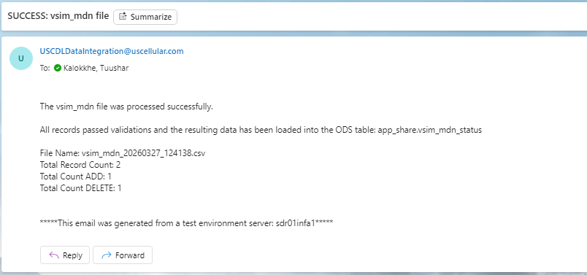

Test Id | Module Tested | Condition Tested | Test Data - Specify Modifications | Expected Results | Actual Results | Reviewed By
2. | Network_Migration | Reject email test. | Added team members email ids for testing purposes, to receive reject email with attached rejected record file. | Reject email should be received. | As expected, email received.  Please refer below screen shot.

Screen Shot:
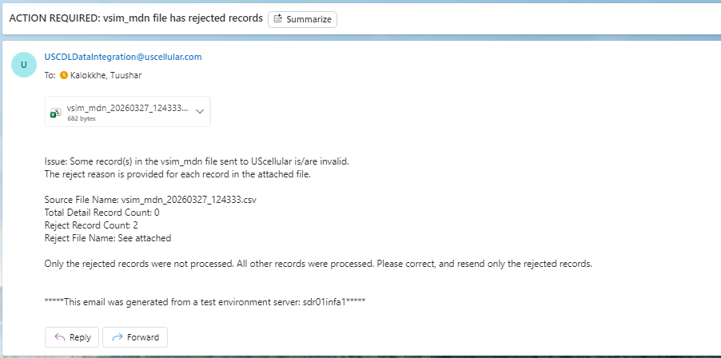

Test Id | Module Tested | Condition Tested | Test Data - Specify Modifications | Expected Results | Actual Results | Reviewed By
3. | Network_Migration | Zero record email test. | Added team members email ids for testing purpose, to receive zero record email. | Zero record email should be received. | As expected, email received.  Please refer below screen shot.

Screen Shot:
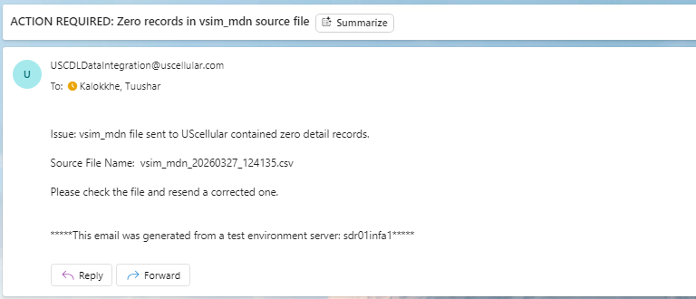

Test Id | Module Tested | Condition Tested | Test Data - Specify Modifications | Expected Results | Actual Results | Reviewed By
4. | Network_Migration | New records insert into the target. | Added new sample data for testing purpose. | Sample data should be inserted into the target. | As expected, email received.  Please refer below screen shot.

Source Records:
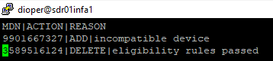
Target Records:
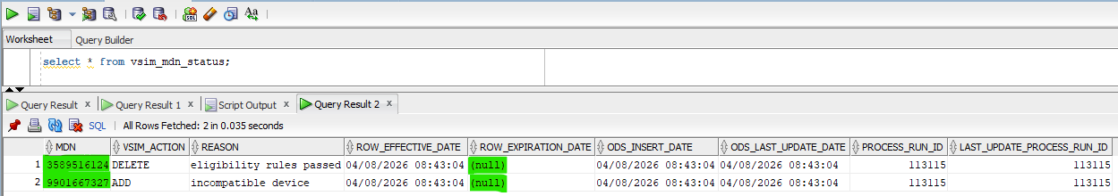

Test Id | Module Tested | Condition Tested | Test Data - Specify Modifications | Expected Results | Actual Results | Reviewed By
5. | Network_Migration | Old records are update and insert into the target. | Run job with below source data, the records which are present in the target need to be updated. | Old data should be updated to the target and new records have been inserted. | As expected, email received.  Please refer below screen shot.

Source Records:
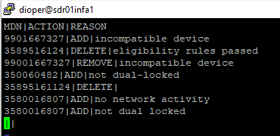
Target Records:
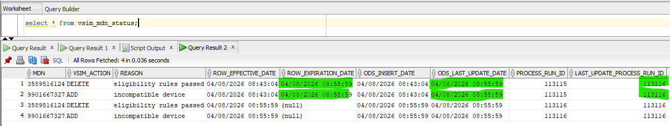
Rejected Records with Reason:

Test Id | Module Tested | Condition Tested | Test Data - Specify Modifications | Expected Results | Actual Results | Reviewed By
6. | Network_Migration | New record insert and old record update into the target also insert the new record. | Adding one new and one old record to check inserting or updating. | New record should be inserted, and old record should be updated into the target with new insert. | As expected, email received.  Please refer below screen shot.

Source Records:
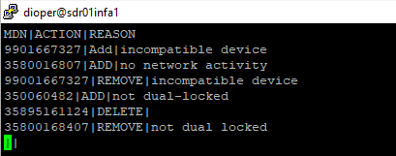
Target Records:
